
Celebrating your community

Road closure for residential street parties

Name of person:

Organisation (if applicable):
Contact address (including postcode):
Telephone number (daytime):
Telephone number (evening):
Email address:
Please state the location of the event/street party, names of streets/roads and post codes.
(If your street party will not include the full road please provide details of house numbers affected and or junctions affected)
Date and time of road closure



What time do you want to close the road for your event/street party? (Please provide start and finish time, taking into consideration your set up and pack away time)
PLEASE NOTE- Last date for applications for road closures is 2 weeks prior to the event.

If you plan to close only a section of the road(s), where will the closure begin and end?
From:
To:

Give a brief list of properties affected. This means any property, residential or commercial, which is located on or accessed only by the road(s) you wish to close – e.g. Cedar Close numbers 1-20 and numbers 21-98

Are any of the roads to be closed used by through traffic?
YES/NO?

If yes, you may need to send a traffic plan showing the extent of the closure and an alternative route for traffic.
Are you planning on closing a road that is part of a bus route?
YES/NO?

If yes, the bus company will need to be consulted.

Will access for emergency vehicles (if required) be readily available at all times?
YES/NO?


If not you will need to change your plans to accommodate them.

How will people know the road has been closed off - have you thought about barriers/diversion signs needed?

If yes, can you say what you will be doing?

If no, you can speak to your council or Streets Alive (www.streetparty.org.uk) who will be able to help you with street signs.

Has a consultation or conversation taken place with all residents?
Yes
No

Have most residents agreed to this event?
YES/NO?

The council will want to ensure most people are happy with this event, so if there are any objections you should let them know. They may be able to help you resolve any objections. Not everyone will be able to participate so let everyone know what time the party will start and end (you may want to finish by 9pm to minimise noise).
If you are planning a road closure you will also need to consult businesses in the wider area that may be affected. Have you already consulted all premises about the road closure?
YES/NO?

If yes, please attach a copy of your consultation invitation/notice and confirm the date it was sent:

Will amplified music be played?
Yes
No

How will waste be disposed of after the event?

Will bunting be placed on highways or street furniture/lighting columns etc?
Yes
No
Maybe

Will obstacles be placed on highways?
Yes
No

What happens next?
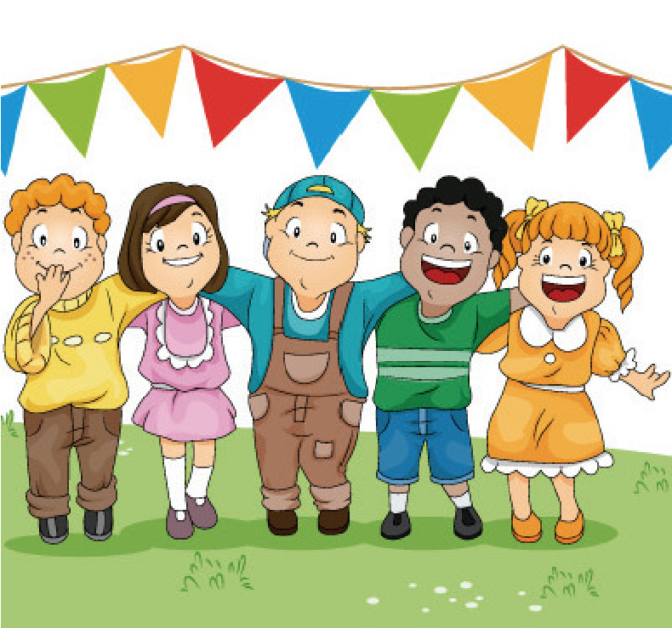
Once you’ve completed a form and sent it to your local council, they will look at what you are proposing, will process your application for road closure and will let you know if there is anything else you need to consider.
Please email to raswa@redcar-cleveland.gov.uk

We hope this guidance has made things easier for you. Good luck with your event.

